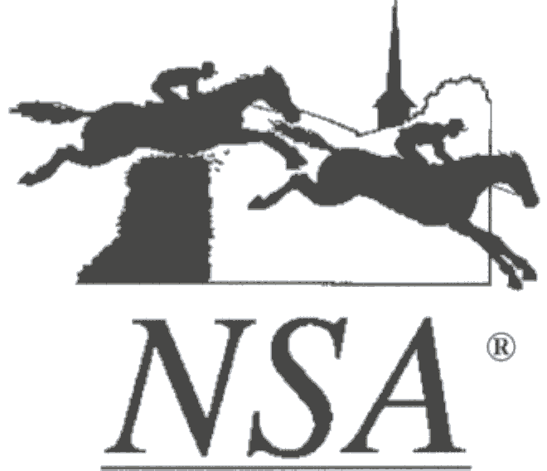

NATIONAL STEEPLECHASE ASSOCIATION

400 Fair Hill Drive
Elkton, Maryland 21921
Phone 410-392-0700 ● Fax 410-392-0706

STEWARDS’ REPORT

RACE MEETING: Radnor (Malvern, Pa) DATE: 5/17/2025.

WEATHER: Partly cloudy, breezy
COURSE CONDITION:
Compaction: 70(soft)
Moisture: 9(wet)

CLERK OF SCALES: Jake Chalfin STARTER: Barry Watson

STEWARDS: Rug Howard
Charlie Fleischmann
Brook Hawkins
Teena Appleby (Safety Steward)

OFFICIAL ACTIONS: By order of the Stewards Advisory Committee the Safety Steward randomly searched 5 trucks and trailers and 10 trainers’ tack trunks. The Safety Steward was asked to stop searching trucks and trailers at 1:00 when racing commenced. A needle and syringe was found in trainer Sandra Webb’s truck by Safety Steward Teena Appleby. Sandra Webb met with the Stewards and her 5 horses were scratched. A bottle of Banamine was found in Trainer Jack Fisher’s truck by Safety Steward Teena Appleby. The Stewards spoke with Trainer Fisher and his two horses were scratched. Both cases have been referred to the Stewards Advisory Committee for adjudication.

OFFICIAL COMMENTS: The Officials’ meeting and the Jockeys’ meeting were held as scheduled. The timber fences are problematic as almost all the top rails were knocked down on the first turn of the race. The race committee should consider returning to conventional post and rail jumps as opposed to the strapped in rails. The Stewards suggest that there should be only one hurdle in the stretch instead of two.

Race 1: WALKER’S GAP was scratched. Change the rider on WILMA FLINTSHIRE to Luke Carberry. BEAUTIFUL GORGEOUS lost the rider at the first. Jockey Mulqueen was cleared to ride. JUST ANOTHER ONE fell at the last fence. Jockey Declan Caroll was cleared to ride. WILMA FLINTSHIRE was pulled up at the second to last. Reported tired.

Race 2: Change the rider on PROJECT TWO(IRE) to Jordan Canavan. ANZIO, THE BUTLER
YATES(IRE), and CORKY LEMON were scratched. KELMSCOTT(IRE) dwelt at the start and
lost considerable ground.

Race 3: RUCKER ROAD(IRE), SEIZING THE DREAM, DOESN’T STING, & BRIGHT EYED
EAGLE were scratched. Change of rider on AUCTION KINGDOM to Graham Watters. The
rider on LIGHTNING ROD is Declan Carrol. LOW COUNTRY was pulled up before the second
to last. I CAN ONLY IMAGINE was pulled up before the second to last.

Race 4: MISSION MAN, RISK TAKING, AMERICAN WAR HERO, AVAKATE, & PHILIP MY
DEAR were scratched. The rider on BOLD LOOK was Mel Boucher. Change of rider on RED
TONE to Dan Nevin. Change of rider on TOP OF THE FIELD(IRE) to Bernie Dalton. DENIS
ANTHONY lost its rider at the 6th. Jockey Conor Tierney was cleared to ride.

Race 5: CRIMSONE LILLE & THATSMYBOXER were scratched. The rider on MADE THE CUT
was Mel Boucher. Change of rider on SILLY LILLY to Jordan Canavan. VON HOFF pulled up at
the 9th. KING OF TSAVO(GB), TIGER PAW, MADE THE CUT, & SILLY LILY were pulled up
before the second to last.

Respectfully Submitted,

Rug Howard
Presiding Steward

